**Introduction to Programming EE2310 Homework 5-2**

**103061142 楊淳佑**

**Problem**

Create a menu of a customer service center to simulate the process when a customer call for service. Generate 100 customer records and save below data.

* Total number of customers visited,
* The number of menu items selected by a user,
* Total number of times each menu item is selected.

Analyze the data of HW5-1 and the data which is generated automatically.

**My Solution**

* Generating 100 customer records: using rand() function to simulate customers options. In order to make the random number table more randomized, the seed (the number of customers * current time) will update every time when the previous “customer” logout.
* Analyze the data: When a menu was selected, a corresponding counting variable will be added 1. When the program generated 100 sets of data, the program will print all the counting variables on the bottom of the log file, then break from the loop.

**Additional Features**

* The problem of not using proper structured programming method has been fixed this time.
* The generating process of address information is not compleated.

**Program Flow & Structure**

**Functions**

* int Login(): To generate the user ID and get the user’s name from the name pool. Save the user information into target file.
* int main(): The first level menu. Also will check the login status. If the user is not logged in (id==0), it will call Login().
* int inq(): The second level menu.
* int productModel(): To pick a product by a random number.
* int productNumber(): To generate a number from 10001 to 39999, and check if it is valid number (the range varies by different model).
* int Repair: Call productModel() and productNumber() first, then generate the purchase date. Print out the repair number and the bill if the warranty has expired in the end.
* int Return: Call productModel() and productNumber()first, then generate the purchase date. Print out the return number in the end.

**Flow Chart (Next Page)**

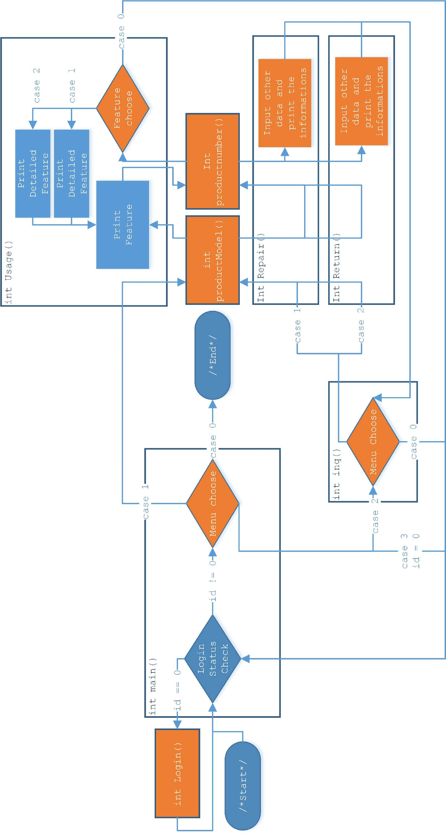

**Output Result**

SystemLog.txt

--------------------

Tue Oct 28 21:19:17 2014

Name = Ivan

ID = 9

> home > usage > home > inquire > return

ReturnNo.0000001

|-ProductModel = 1

|-ProductNumber = 20077

|-PurchaseDate = 2003.2.15

steps = 5

--------------------

***(Omitted)***

--------------------

Tue Oct 28 21:19:26 2014

Name = Jason

ID = 10

> home

steps = 1

------------------------------

SYSTEM SUMMARY

Total Customers = 100

Usage Menu Selected = 126

Inquiry Menu Selected = 418

Repair Selected = 141

Return Selected = 147